Some properties are inherited by default no matter how deep nested elements

        <div id="box">

            <section>

                <section >This is some text inside the box.<section>

            </section>

        </div>

#box {

      background-color: brown;

      padding: 100px;

}

“This is some text…” will also have background color brown. The inheritance works on those properties for all selectors: tags, classes, id.

Some properties like `padding` are not inherited, to inherit them it should be set to `inherit`

#sec {

  padding: inherit;

}

But it inherits from close parent, not from grandparents:

        <div id="box">

            <section>

                <section id="sec" >This is some text inside the box.<section>

            </section>

        </div>

#box {

      background-color: brown;

      padding: 100px;

}

#sec {

  padding: inherit;

}

The padding of #sec will be 0px because the padding of parent <section> is default 0px.

To select all descendants (children, grandchildren etc.) write

.class \* {

  padding: 10px;

}

To select only first-level children:

.class > \* {

  padding: 10px;

}

Select first elements B directly followed by A elements:

A + B {

  padding: 10px

}

Select all elements B followed by A element (on the same level of nesting):

A ~ B {

  padding: 10px

}

Select first child(or grandchild, etc.) of element:

div p:first-child{

  padding: 10px;

}

Select every element that is the 8th child of another element:

:nth-child(8){

  padding: 10px;

}

In flex-box the `flex` property works bad:

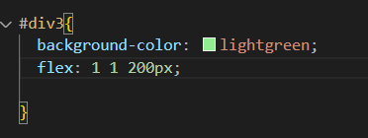

It’s ignore 200px size.

So I prefer to use related parameters:

#div1{

  background-color: coral;

  width: 100%;

  flex-shrink: 1;

}

#div2{

  background-color: lightblue;

  width: 200px;

  flex-shrink: 0;

}

#div3{

  background-color: lightgreen;

  width: 200px;

  flex-shrink: 0;

}

The div1 take all the rest place and only div1 is shrink.

Don’t use flex-grow and width.

#div1{

  background-color: coral;

  min-width: 100px;

  width: 50%;

}

#div2{

  background-color: lightblue;

  min-width: 100px;

  width: 100%;

}

#div3{

  background-color: lightgreen;

  width: 200px;

  flex-shrink: 0;

}

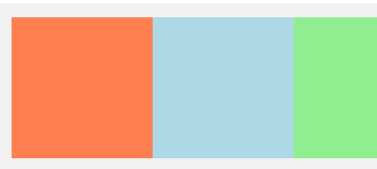div2 is twice wider than div1, but if shrink – 100px both: